## Control Break Processing - Creating a Summary Report

It is quite often that a programmers will be asked to create a simple summary (no detail) report.

## INPUT 1: DD DSN=SHARE.GET433.STUDENT.DATA(CBLB),DISP=SHR

* Name 1 thru 20 PIC X(20)
* Address 21 thru 40 PIC X(20)
* Social Security No 41 thru 49 PIC 9(9)
* Number of Credits 50 thru 51 PIC 99
* Year of graduation 52 thru 55 PIC 9(4)
* Sequential zOS file, 80 bytes per record
* DISP=SHR - means all can use as for input

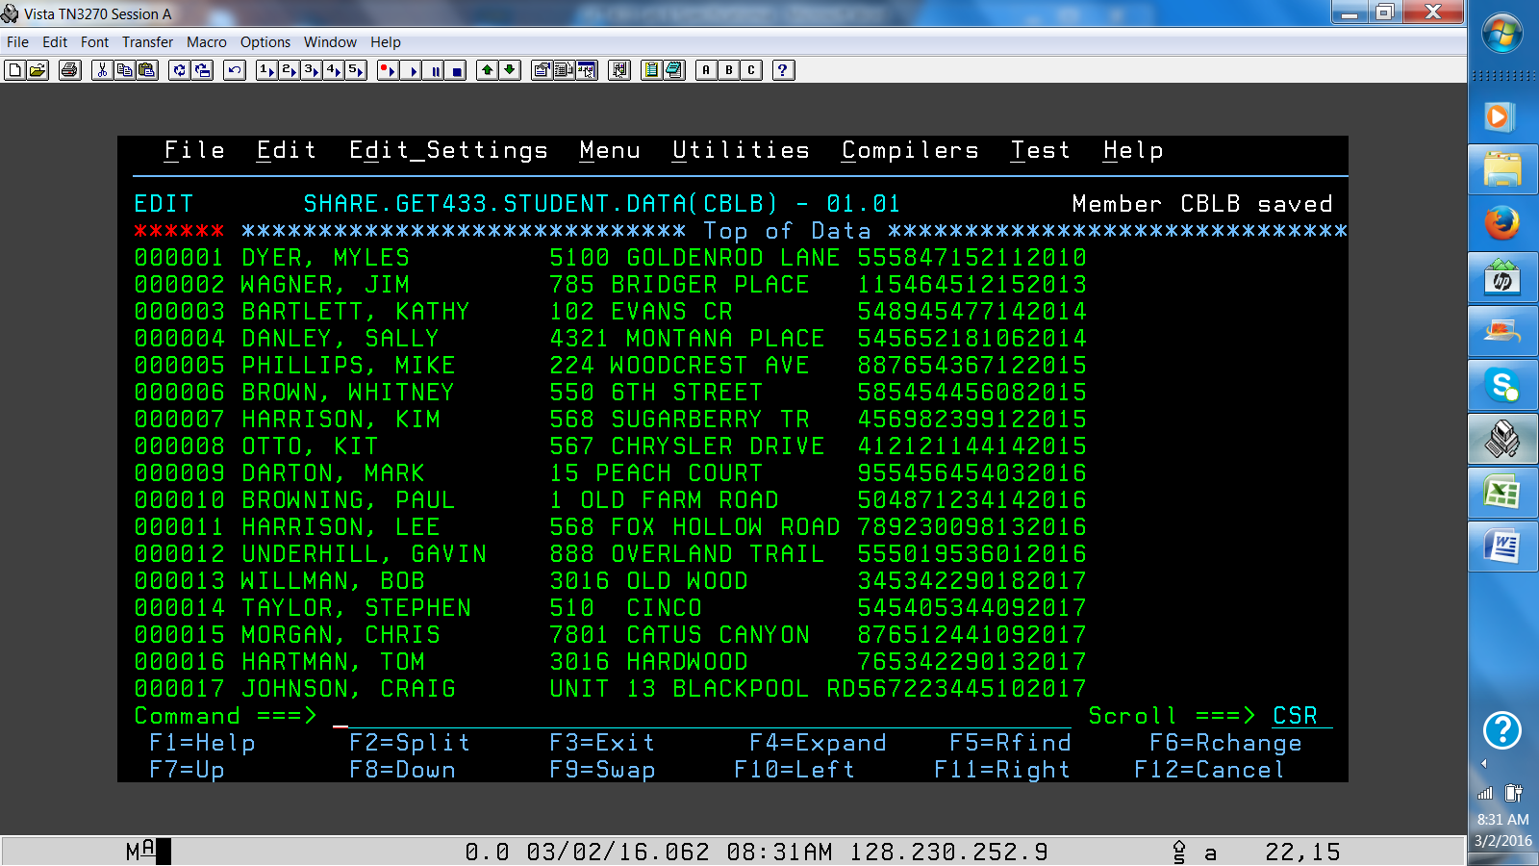

**PROCESS:**

* **Create a COBOL base program in your source library**
* **Read through the input file - and create a report of only one line per each year of graduation.**
* **The tuition can be calculated by multiplying the credits times $800 / credit.**
* **Define the INPUTs (SELECT, FD, OPEN, READ, CLOSE)**
* **Define the OUTPUT (SELECT, FD, OPEN, WRITE, CLOSE)**
* **Write the necessary PROCEDURE DIVISION statements to read thru all of the input file. For each record populate the output record and write the record to the output print file.**
* **Take a screen shot of your output file and place it in Blackboard.**

**OUTPUT:**

**Record layout: See attached**

**//OFILE DD DSN=SUS00nn.GET239.LAB6.OUTPUT,**

**// DISP=(NEW,CATLG,DELETE),**

**// DCB=(BLKSIZE=0,LRECL=80,RECFM=FB),**

**// SPACE=(CYL,(1,1),RLSE),**

**// UNIT=SYSDA**